Default Routing (Default Configuration of Router)
Lab Practical 2:
First Take 2 Routers (Ex: 8421), 2 Switches And 4 Pc’s , Connect Routers Using Crossover Cable , Switches And Pc’s Using Straight Through Cables.

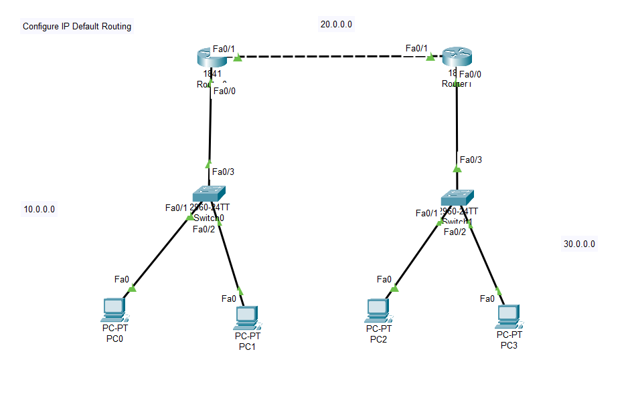
Open Router 0 – CLI prompt then type following commands
Router>enable
Router#configure terminal
Router(config)# interface fastEthernet 0/0
Router(config-if)# ip address 10.0.0.1 255.0.0.0
Router(config-if)#no shutdown
Open pc 0 – desktop—ip configuration – provide ipv4 address (10.0.0.2) – subnet mask (255.0.0.0) – default gateway (10.0.0.1)

Open pc 1 – desktop—ip configuration – provide ipv4 address (10.0.0.3) – subnet mask (255.0.0.0) – default gateway (10.0.0.1)

Open Router 0 – CLI prompt then type following commands
R1(config-if)#exit
R1(config)# interface fastEthernet 0/1
R1(config-if)# ip address 20.0.0.1 255.0.0.0
R1(config-if)# no shutdown

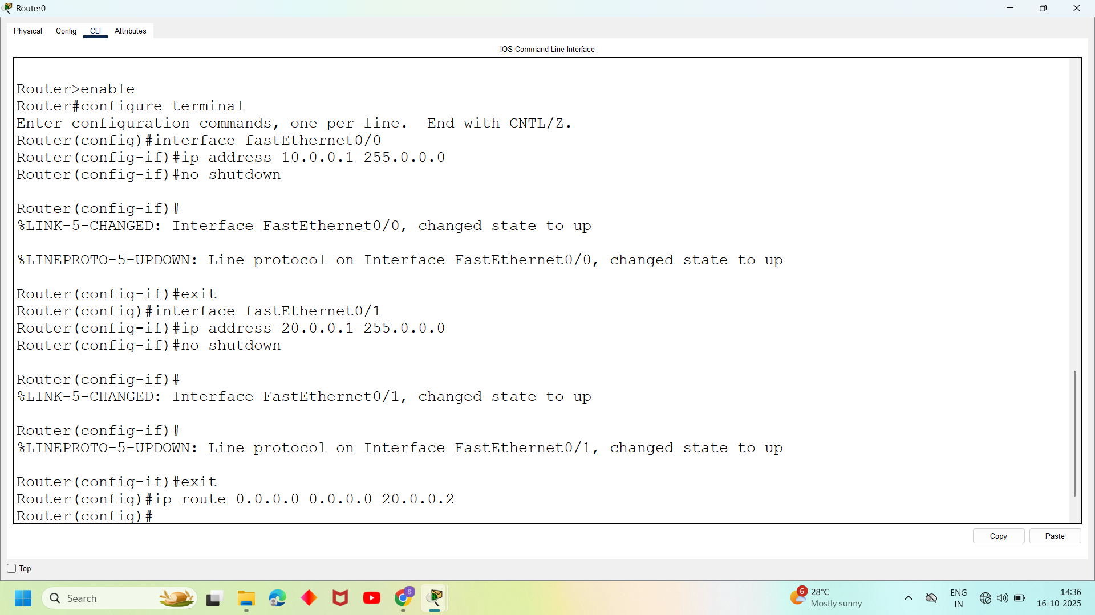

Open Router 1 – CLI prompt then type following commands
Router>enable
Router#configure terminal
Router(config)# interface fastEthernet 0/0
Router(config-if)# ip address 30.0.0.1 255.0.0.0
Router(config-if)#no shutdown

Open pc 2 – desktop—ip configuration – provide ipv4 address (30.0.0.2) – subnet mask (255.0.0.0) – default gateway (30.0.0.1)

Open pc 3 – desktop—ip configuration – provide ipv4 address (30.0.0.3) – subnet mask (255.0.0.0) – default gateway (30.0.0.1)
Open Router 1 – CLI prompt then type following commands
R2(config-if)#exit
R2(config)# interface fastEthernet 0/1
R2(config-if)# ip address 20.0.0.2 255.0.0.0
R2(config-if)# no shutdown

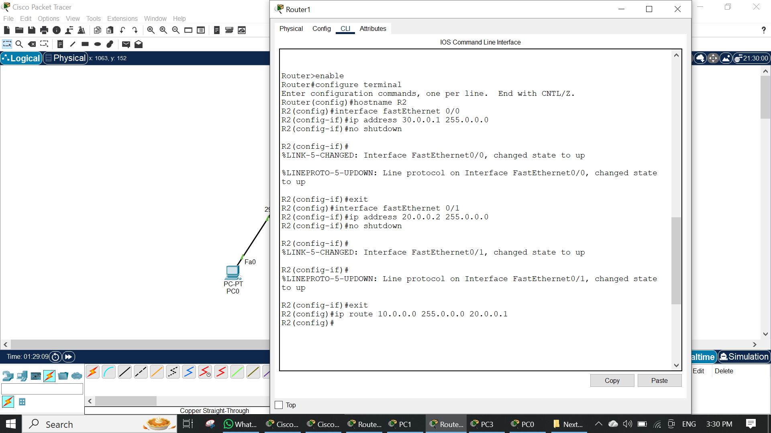

Both Routers Are Turned On At This Stage And Its Connected Devices (Switch, Pc’s) Also Turned O Showing Green Signals.

But If We Ping From Pc’0 To Pc’3 Ip It Shows Destination Is Not Reachable For This We Need Ip Route Command :
Open Router 0 – CLI prompt then type following command
Router(config-if)#exit
Router(config)# ip route 0.0.0.0 0.0.0.0 20.0.0.2

Open Router 1 – CLI prompt then type following command

Router(config-if)#exit
Router(config)# ip route 0.0.0.0 0.0.0.0 20.0.0.1

Open pc 0 – cmd prompt – type command

>ping 30.0.0.2
We will get Reply back (acknowledgement ) from pc’s
This Is How We Have Done Static Routing.

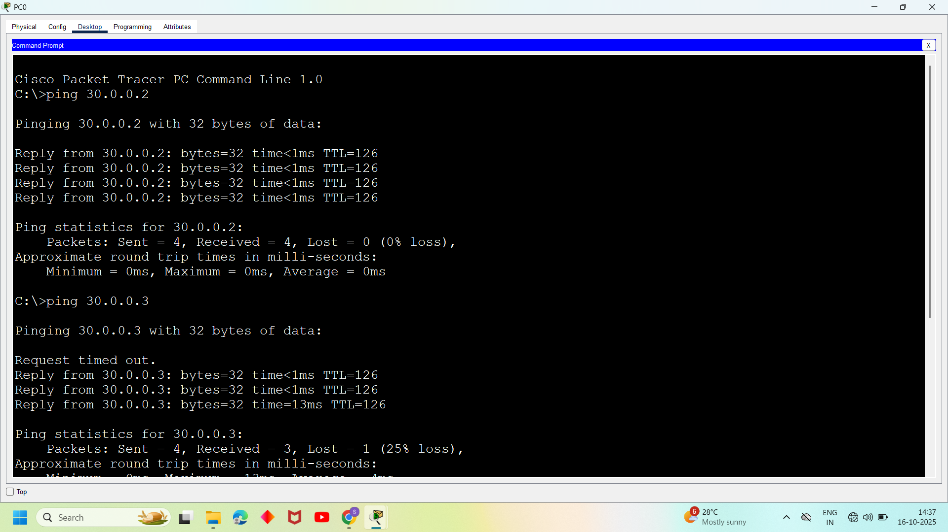
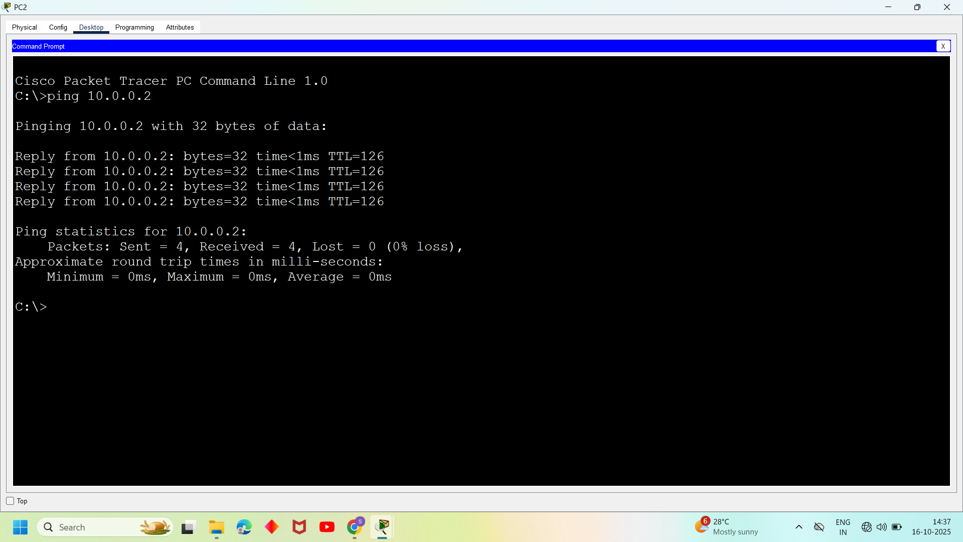
- First Take 3 Routers (Ex: 1841), 3 Switches And 6 Pc’s, Connect Routers Using Crossover Cable , Switches And Pc’s Using Straight Through Cables.

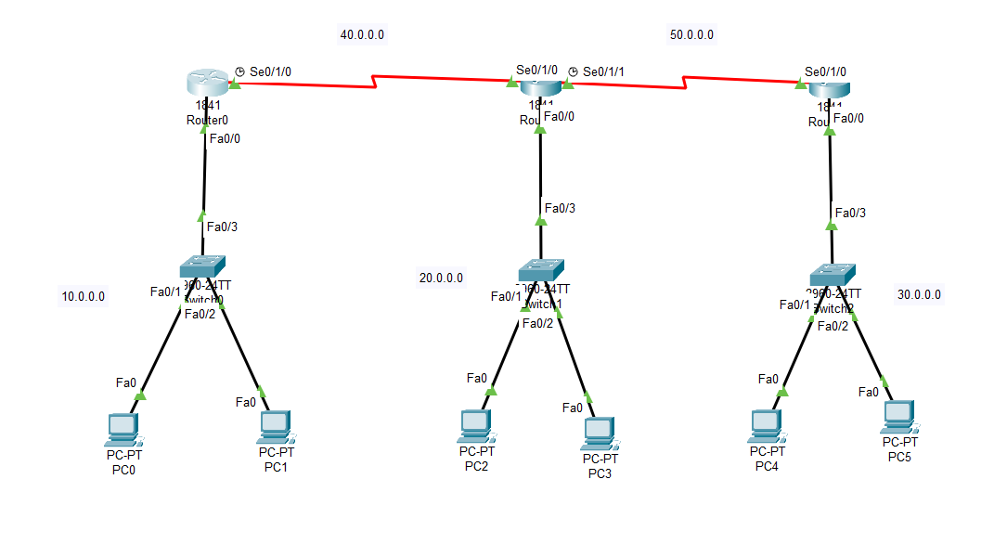
Open Router 0 – CLI prompt then type following commands
Router>enable
Router#configure terminal
Router(config)# interface fastEthernet 0/0
Router(config-if)# ip address 10.0.0.1 255.0.0.0
Router(config-if)#no shutdown
Open pc 0 – desktop—ip configuration – provide ipv4 address (10.0.0.2) – subnet mask (255.0.0.0) – default gateway (10.0.0.1)
Open pc 1 – desktop—ip configuration – provide ipv4 address (10.0.0.3) – subnet mask (255.0.0.0) – default gateway (10.0.0.1)

Open Router 0 – CLI prompt then type following commands
Router(config-if)#exit
Router(config)# interface serial0/1/0
Router(config-if)# ip address 40.0.0.1 255.0.0.0
Router(config-if)# no shutdown

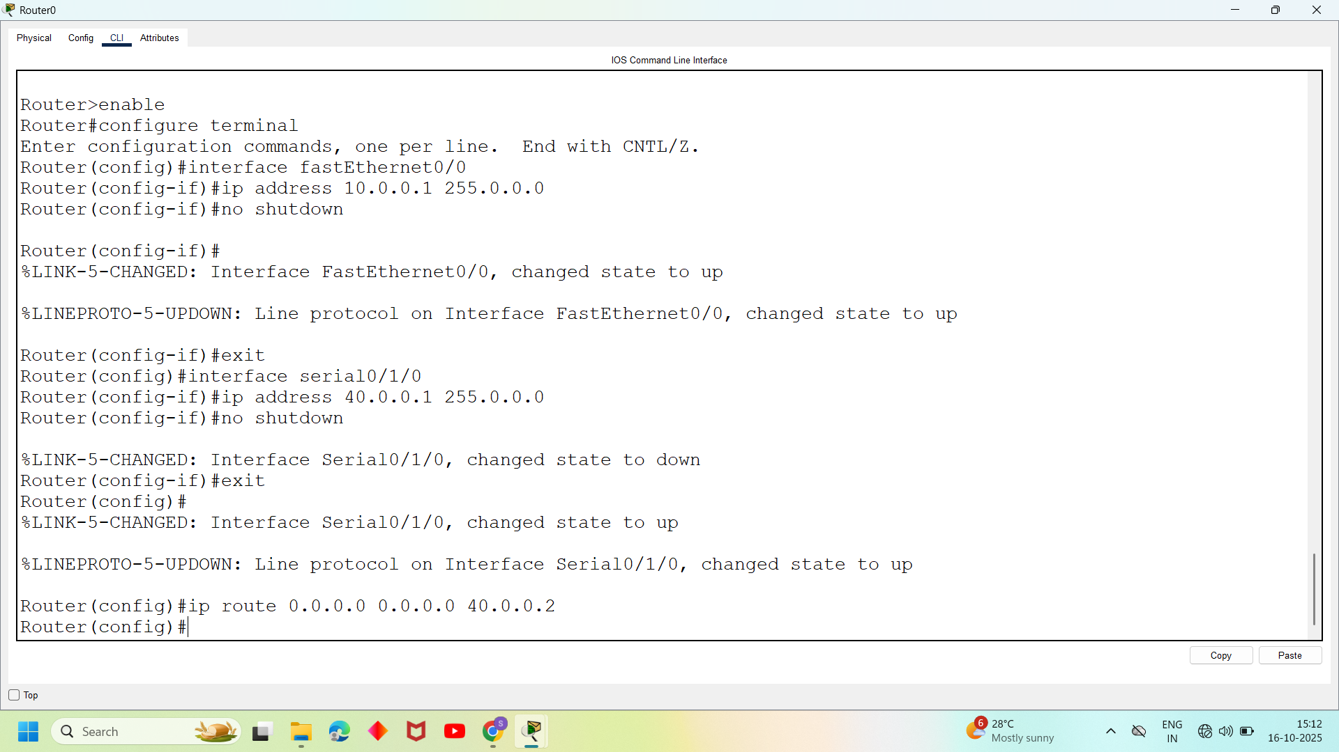

Open Router 1 – CLI prompt then type following commands
Router>enable
Router#configure terminal
Router(config)# interface fastEthernet 0/0
Router(config-if)# ip address 20.0.0.1 255.0.0.0
Router(config-if)#no shutdown

Open pc 2 – desktop—ip configuration – provide ipv4 address (20.0.0.2) – subnet mask (255.0.0.0) – default gateway (20.0.0.1)

Open pc 3 – desktop—ip configuration – provide ipv4 address (20.0.0.3) – subnet mask (255.0.0.0) – default gateway (20.0.0.1)

Open Router 1 – CLI prompt then type following commands
Router(config-if)#exit
Router(config)# interface serial0/1/0
Router(config-if)# ip address 40.0.0.2 255.0.0.0
Router(config-if)# no shutdown

Router(config-if)#exit
Router(config)# interface serial0/1/1
Router(config-if)# ip address 50.0.0.1 255.0.0.0
Router(config-if)# no shutdown

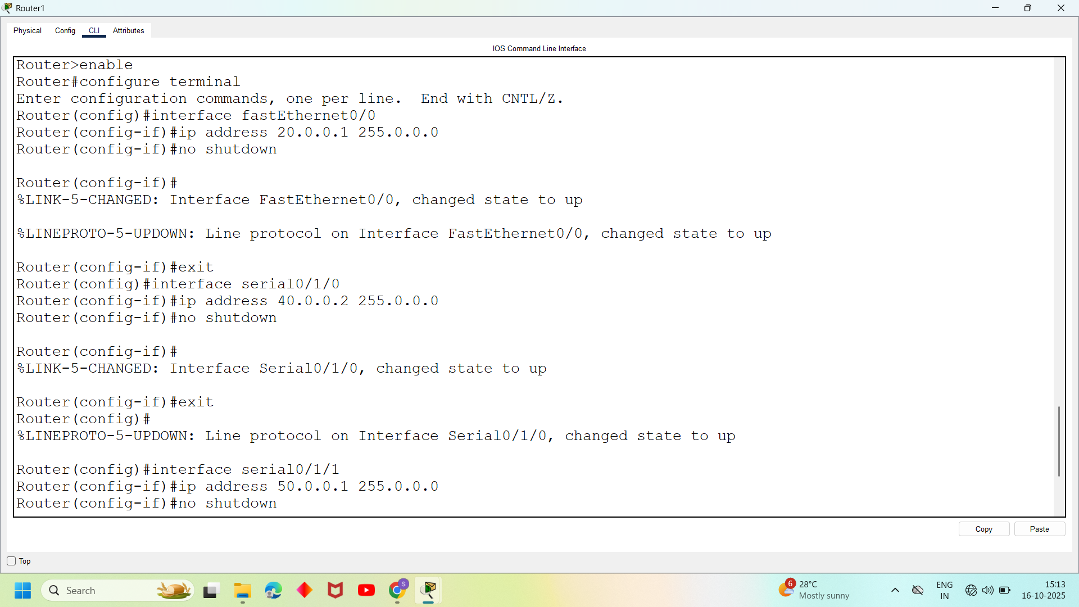

Open Router 2 – CLI prompt then type following commands
Router>enable
Router#configure terminal
Router(config)# interface fastEthernet 0/0
Router(config-if)# ip address 30.0.0.1 255.0.0.0
Router(config-if)#no shutdown

Open pc 4 – desktop—ip configuration – provide ipv4 address (30.0.0.2) – subnet mask (255.0.0.0) – default gateway (30.0.0.1)

Open pc 5 – desktop—ip configuration – provide ipv4 address (30.0.0.3) – subnet mask (255.0.0.0) – default gateway (30.0.0.1)

Open Router 2 – CLI prompt then type following commands
Router(config-if)#exit
Router(config)# interface serial0/1/0
Router(config-if)# ip address 50.0.0.2 255.0.0.0
Router(config-if)# no shutdown

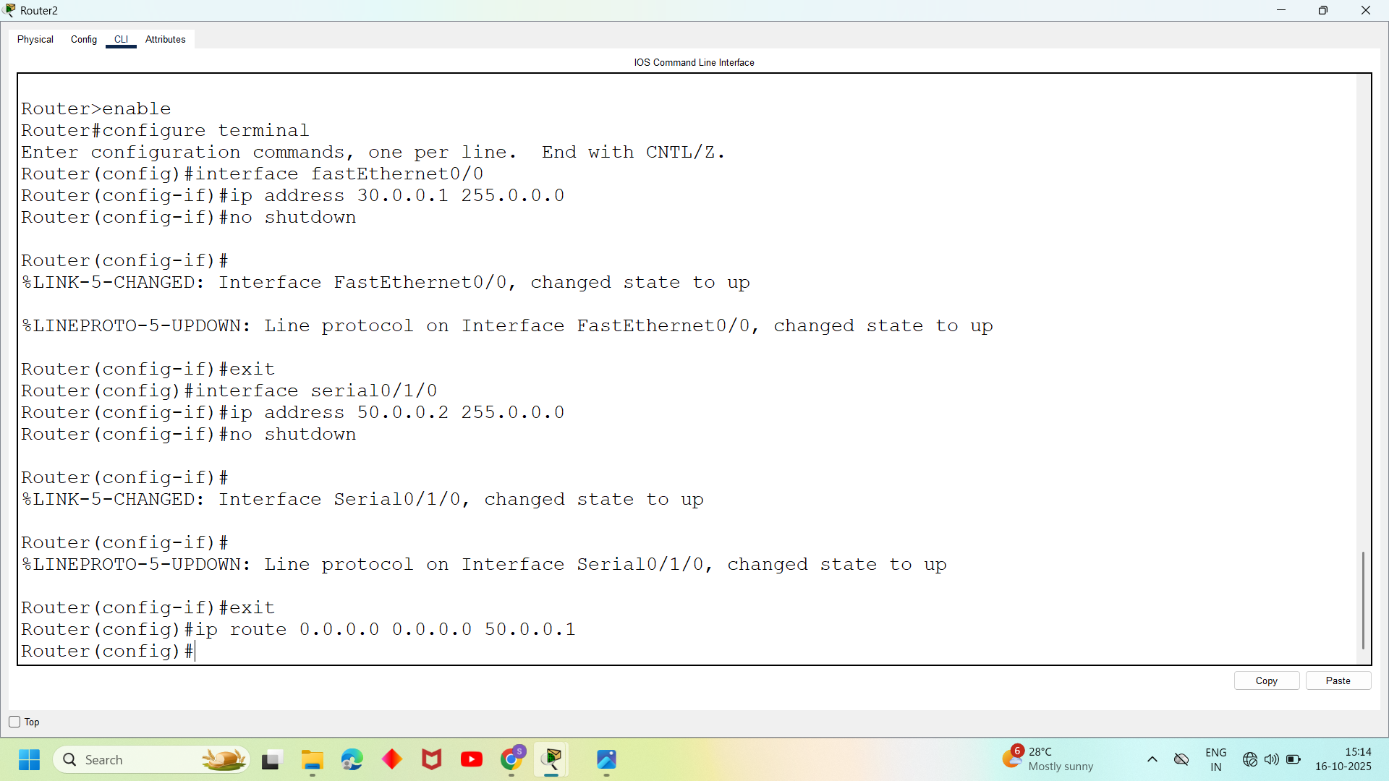
Open Router 0 – CLI prompt then type following command
Router(config-if)#exit
Router(config)#ip route 0.0.0.0 0.0.0.0 40.0.0.2

Open Router 1 – CLI prompt then type following command

Roter(config-if)#exit
Router(config)#ip route 0.0.0.0 0.0.0.0 40.0.0.1
Router(config)#ip route 0.0.0.0 0.0.0.0 50.0.0.2

Open Router 2 – CLI prompt then type following command
Roter(config-if)#exit
Router(config)#ip route 0.0.0.0 0.0.0.0 50.0.0.1

Open pc 0 – cmd prompt – type command
>ping 20.0.0.2

